Ideation Phase
Define the Problem Statements
Date | 25-06-25
Team ID | LTVIP2025TMID47835
Project Name | Resolver
Maximum Marks | 2 Marks

Customer Problem Statement Template:
Create a problem statement to understand your customer's point of view. The Customer
Problem Statement template helps you focus on what matters to create experiences people will
love.
A well-articulated customer problem statement allows you and your team to find the ideal
solution for the challenges your customers face. Throughout the process, you’ll also be able to
empathize with your customers, which helps you better understand how they perceive your
product or service.

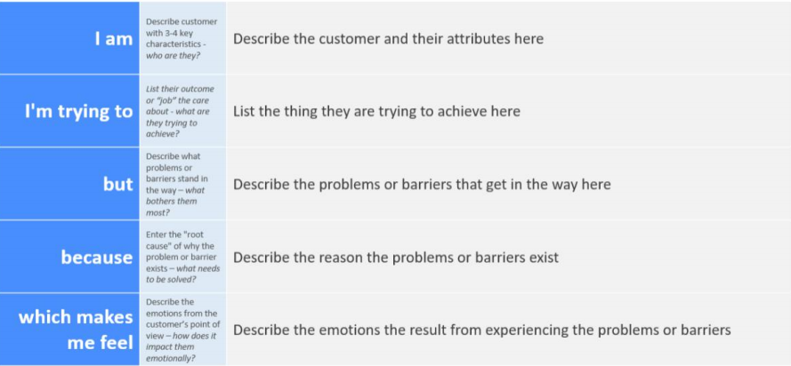
Reference: https://miro.com/templates/customer-problem-statement/

